

DEPARTMENT OF INFORMATION TECHNOLOGY
SCHOOL OF COMPUTING AND INFORMATICS

LOGBOOK: MOBILE APPLICATION DEVELOPMENT
UNIT CODE: BIT4107
NAME: YUSUF ANEMBA
REGNO: BIT/2020/90745
PROJECT NAME: SCHOOL MANAGEMENT APPLICATION

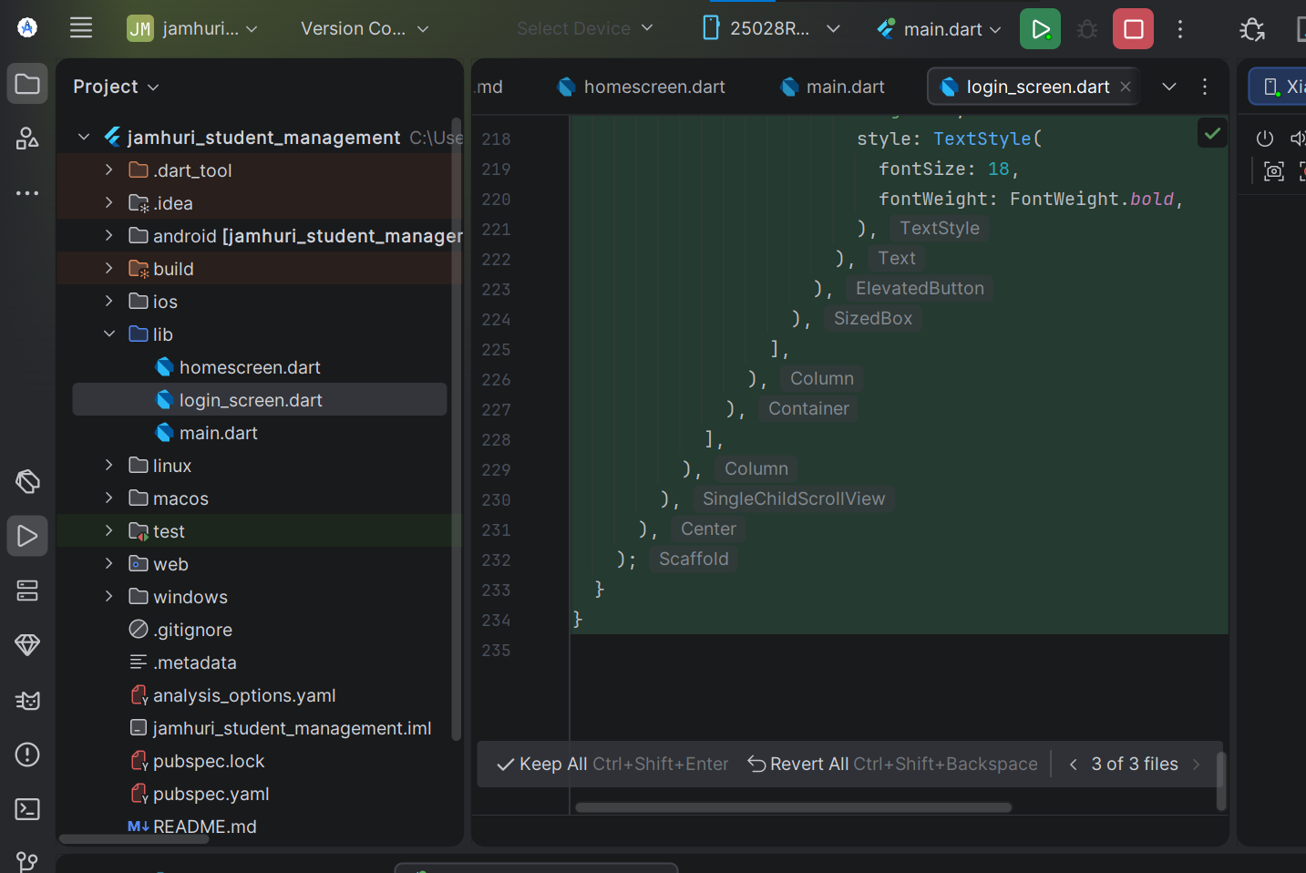
Figure 1.1 screenshot of project development in android studio
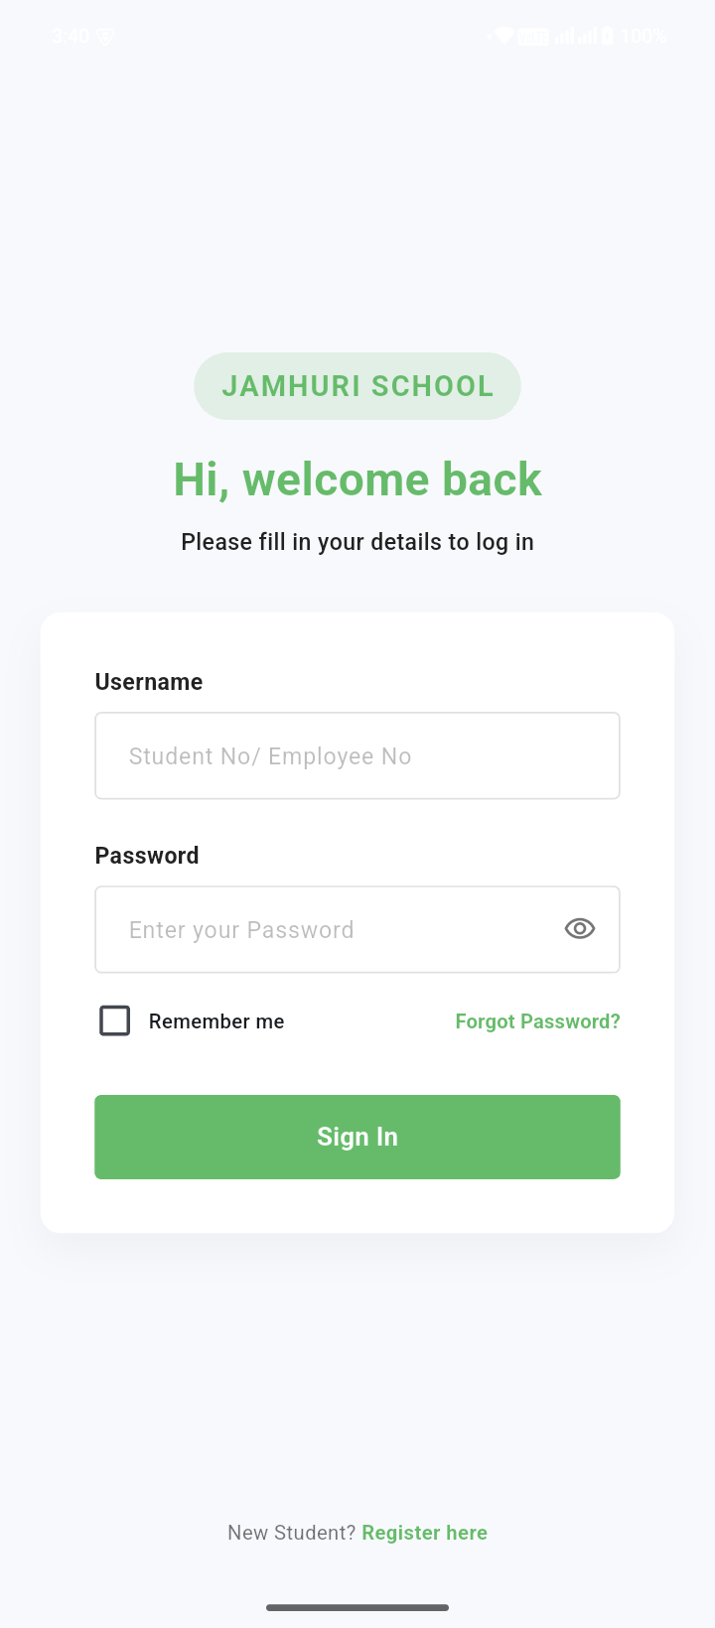
Figure 1.2 login screen of the student mobile application
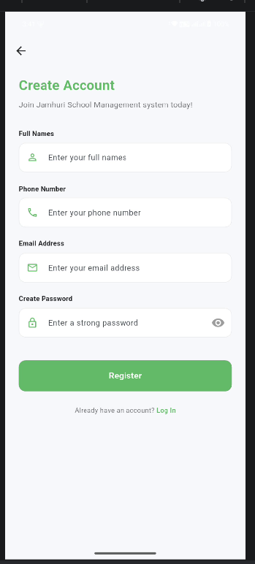
Figure 1.3 registration of new students’ page after clicking the ‘Register here’ button at the bottom

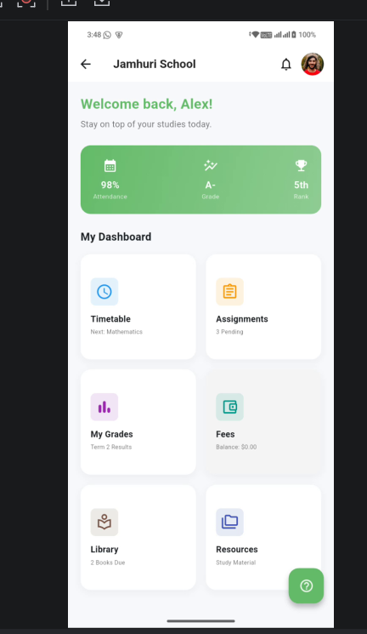
Figure 1.4 after successful login students can view their information.
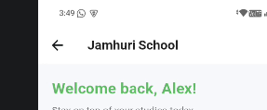
Figure 1.5 navigations bar added.
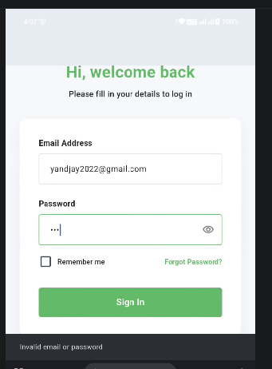
Figure 1.6 created a local database to store student’s login credentials and their information.
When I try to log in, it first checks if there exists that user, if not it prompts you to create an account, if you already have, then input your login details to login

TOOLS AND TECHNOLOGIES USED
For the development of the JAMHURI STUDENT MANAGENT APP, I used the following tools,
- Flutter SDK
- Dart
- SQFlite. Local database to store students’ records.
- Android studio
- Android emulator/ my android phone

